

|  |  |
| --- | --- |
|  |  |

**Design Document**

**OOPMS**

**Wednesday, June 13, 2012**

**Version 0.1**

*Prepared by*

**Ngo Duc Duy**

Revision and Signoff Sheet

Change Record

|  |  |  |  |
| --- | --- | --- | --- |
| **Date** | **Author** | **Version** | **Change reference** |
| 06/05/2012 | Ngo Duc Duy | 0.1 | Create new |
|  |  |  |  |
|  |  |  |  |

Reviewers

|  |  |  |  |
| --- | --- | --- | --- |
| **Name** | **Version** | **Position** | **Date** |
| Manh Hoang Truong | 0.1 | Developer | 12-June-2012 |
| To Cong Thanh Hai | 0.1 | Developer | 12-June-2012 |
| Pham Nguyen Truong Giang | 0.1 | Developer | 12-June-2012 |
| Le Ngoc Thach | 0.1 | Project Manager | 12-June-2012 |

Table of Contents

1 Introduction 30

1.1 Purpose 30

1.2 Scope 30

1.3 Intended Audiences and Document Organization 30

1.4 Acronyms and Abbreviations 30

1.5 References 31

2 Architecture design 31

2.1 Overview 31

2.2 Application Logical Architecture 31

2.1 Component view 33

3 Database design 33

3.1 Entity Relationship Diagram 33

3.2 Schema 34

3.1 Detail Schema 34

4 Application Security 34

4.1 Custom Permission 34

4.2 Security Group 34

4.3 Security Group v.s. List 35

5 Workflow and Business Processing 31

5.1.1 PM Request 32

6 Interface Design 35

6.1 Layout 35

6.2 Themes 35

7 Details design 35

8 Configuration 36

8.1 Application Configuration 36

8.2 System Configuration 36

9 Packaging and Deployment 36

# Introduction

## Purpose

This document contains the detailed design for to be developed application on target platform. It defines, technically, how applications will operate. Developers will base on this document and corresponding SRS to conduct development plan, task assignment and implementation of the new application.

## Scope

This document is prepared for the application OOPMS in scope of the capstone project of FU K4B.

## Intended Audiences and Document Organization

This document is intended for:

* Development team: Developers and Testers
* Rollout Technical Team: Responsible for deploying applications to UAT and Production environments.
* Customer Representatives: Responsible to review & approve the document.

Below are main sections of the document:

* **Introduction** : This section describes the general introduction of this document
* **Architecture Design :** This section describes the high-level technical assessments and decisions for the application.
* **Technical Solutions :** This section describes mechanism used in the project.
* **Data Design**: This section describesin detail how data is structured and manipulated in this application.
* **Interface Design:** This section describesin detail how UI is designed in general ( layout , theme ).
* **Application Security**: This section describles security matrix in detail
* **Configuration:** This section describes all configuration needed for the application to function properly.
* **Packaging and Deployment:** This section describles how applications could be packaged and deployed.
* Note:Please refer section 1.4 for all acronyms and abbreviations you may encounter within this document.

## Acronyms and Abbreviations

|  |  |  |
| --- | --- | --- |
| # | Item | Description |
| 1 | ASP | ActiveX Server Page |
| 2 | JVM | Java Virtual Machine |
| 3 | HTTP | Hypertext-Transfer Protocol |
| 4 | MVC | Model – View – Control |
| 5 | DAO | Data Access Object, this object is responsible for attaching to a system, extracting some information, based on specific requirements, and creating a value object. |
| 6 | OOPMS | Open-One Project Management System |

## References

|  |  |  |  |  |
| --- | --- | --- | --- | --- |
| # | Title | Version | File Name / Link | Description |
| 1 | SRS Document | 1.0 |  |  |
| 2 | User Requirement | 1.0 |  |  |

Table 1.1: List of References

# Architecture design

## User case view

**Table of Use Case**

### Overview

Main flow of Use Case

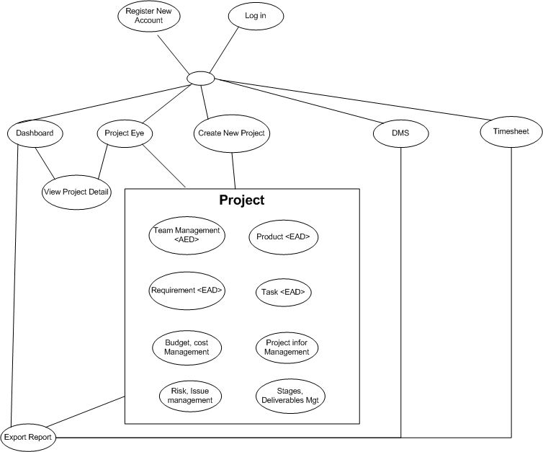

## Architectural Representation

The following diagram shows the primary tiers in the proposed n-tier architecture. This diagram shows the main layers in this architecture and the vision of how they fit together.



Figure 1 – N-tier architecture of SD System

### Presentation Layer

This layer controls the display to the end user. For the presentation layer of OOPMS, the development framework is based on MVC Model architecture. The framework is responsible for:

Managing requests/responses from/to the clients.

Controlling display to the end user.

Assembling a model that can be presented in a view.

Performing UI validation.

Providing a controller to delegate calls to business logic and other upstream processes.

Handling exceptions from other layers.

### Business Layer

This layer manages the business processing rules and logic.

Handling application business logic and business validation.

Managing transactions.

Allowing interfaces for interaction with other layers.

Managing dependencies between business level objects.

Adding flexibility between the presentation and the persistence layer so they do not directly communicate with each other.

Exposing a context to the business layer from the presentation layer to obtain business services.

Managing implementations from the business logic to the persistence layer.

### Data Access Layer

This layer manages access to persistent storage. The primary reason to separate data access from the rest of the application is that it is easier to switch data sources and share Data Access Objects (DAOs) between applications.

This layer manages reading, writing, updating, and deleting stored data.

### Data Layer

In OOPMS, the storage is managed by a relational database. Oracle 10g Express is used for this layer to provide the management of stored data.

## 2.3 Packages/Components view



### UI Components

This package includes the implementation for the JSP, MVC architecture proposed to be used in the Presentation Layer to handle the display to the end user.

**Validation**: All validation of incoming requests parameters to the server should be validated using JavaScript Validation or JSP client side control .

### Business Object

This package includes the implementation of business objects. **Business Object** (BO) layer is used to perform the business operations. The Business Object layer will access the DAO to access database. Transactions should be managed within this business layer.

### Transfer Data Objects ( Entity )

Transfer Data Objects is java class, contains lightweight structures for related business information. These are sometimes referred to as data transfer objects. A value object (VO) is a lightweight, serializable object that structures groups of data items into a single logical construct. .In addition, VOs are useful in communication among all layers of the application.

### Data Access Object

This package includes the implementation of Data Access Object. Using Oracle CLient object here to make the application more flexible to access database. Oracle Client object includes basic functions to work with database: *select, insert, update, delete*.

### Exceptions

This package will include all general exceptions that will typically used by more than one package. The try-catch clauses should be kept to a minimum.

### Utils

This package includes all utilities will be wisely used in the modules.

### Logging

This package includes implemented logging classes.

# Technical Solutions

## Exception handling mechanism

The try-catch clauses should be kept to a minimum.

Whenever an exception raise , system will log exception detail to Windows event and redirect user to Error page to display standard error message!

## Logging mechanism

Logging is an important and pretty useful mechanism for every application. It can help developers to debug and improve their code or test it’s functionality. In OOPMS, logging component is developed based on log4j logging API.

# Database design

## Entity Relationship Diagram

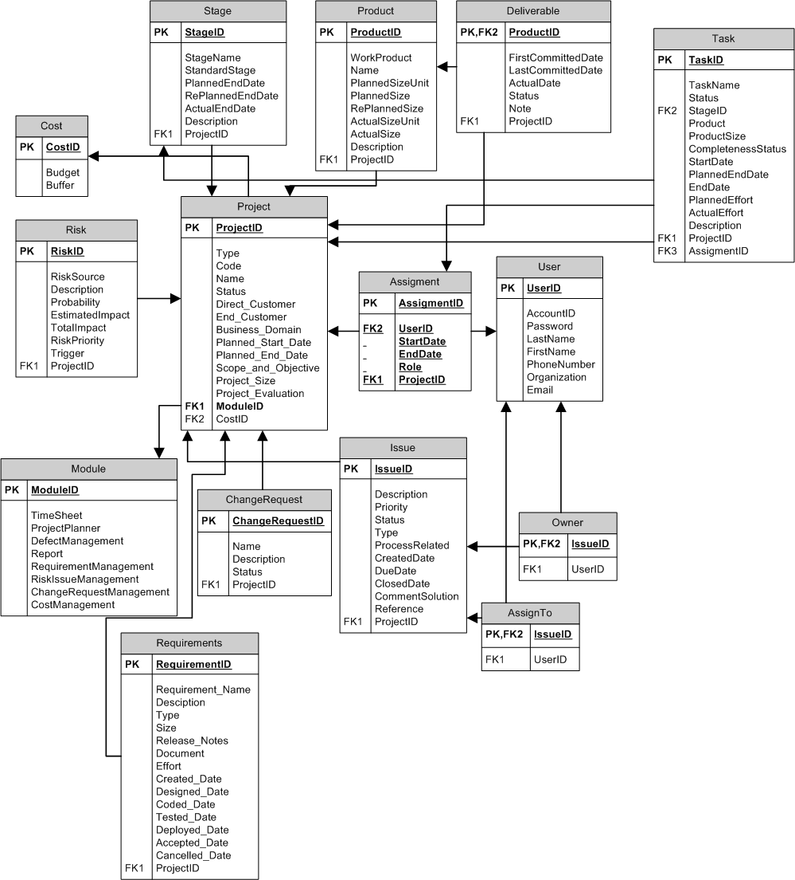

## Schema

**Overview**

|  |  |  |
| --- | --- | --- |
| **#** | **Name** | **Description** |
| 1 | Project | Project with its information: name, type, code.. |
| 2 | Stage | Stage of software development process |
| 3 | Product | Product from development process |
| 4 | Deliverable | Product to be summited to customers |
| 5 | Task | Task assign to team members |
| 6 | Cost | Cost management |
| 7 | Risk | Risk management |
| 8 | Assignment | Assignment to user |
| 9 | User | User |
| 10 | Module | Module of project |
| 11 | ChangeRequest | Change Request management |
| 12 | Issue | Issue Management |
| 13 | Owner | Owner of issue |
| 14 | AssignTo | Assigned member of issue |
| 15 | Requirement | Requirement Management |

## Detail Schema

|  |  |  |  |  |  |  |  |  |  |
| --- | --- | --- | --- | --- | --- | --- | --- | --- | --- |
| **Project table** | | | | | | | | | |
| **No** | **Field name** | **Type** | **Max Length** | | **Null** | **Unique** | **P/F Key** | **Description** | |
| 1 | ProjectID | CHAR | 10 | |  |  | PK | PK – ID of project | |
| 2 | Type | NVARCHAR | 20 | |  |  |  | Type of project | |
| 3 | Code | NVARCHAR | 20 | |  |  |  | Project code | |
| 4 | Name | NVARCHAR | 100 | |  |  |  | Name of project | | of requirement | |  | |  | |  |  |
| 5 | Status | NVARCHAR | 10 | |  |  |  | Status of project | |  | |  | |  | |  |  |
| 6 | DirectCustomer | NVARCHAR | 20 | | X |  |  | Direct customer of project | |  | |  | |  | |  |  |
| 7 | EndCustomer | NVARCHAR | 20 | | X |  |  | End customer of project | |  | |  | |  | |  |  |
| 8 | BusinessDomain | NVARCHAR | 20 | | X |  |  | Business domain of project | |  | |  | |  | |  |  |
| 9 | PlannedStartDate | DATETIME |  | |  |  |  | Planned start date of project | |  | |  | |  | |  |  |
| 10 | PlannedEndDate | DATETIME |  | |  |  |  | Planned end date of project | |  | |  | |  | |  |  |
| 11 | ScopeAndObjective | NVARCHAR | 200 | | X |  |  | Scope and objective of project | |  | |  | |  | |  |  |
| 12 | ProjectSize | INTEGER |  | | X |  |  | Size of project | |  | |  | |  | |  |  |
| 13 | ProjectEvaluation | INTEGER |  | | X |  |  | Project Evaluation | |  | |  | |  | |  |  |
| 14 | ModuleID | CHAR | 10 | |  |  | FK | FK ModuleID of project | |  | |  | |  | |  |  |
| 15 | CostID | CHAR | 10 | |  |  | FK | FK CostID of project | |  | |  | |  | |  |  |
|  | | | |  | | | | |  | |  | |  | |
| **Stage table** | | | | | | | | | |
| **No** | **Field name** | **Type** | **Max Length** | | **Null** | **Unique** | **P/F Key** | **Description** | |
| 1 | StageID | CHAR | 10 | |  |  | PK | PK – ID of stage | |
| 2 | StageName | NVARCHAR | 20 | |  |  |  | Name of stage | |
| 3 | StandardStage | NVARCHAR | 20 | |  |  |  | Standard Stage | |
| 4 | PlannedEndDate | DATETIME |  | |  |  |  | Planned end date of stage | |
| 5 | RePlannedEndDate | DATETIME |  | | X |  |  | Re planned end date of stage | |
| 6 | ActualEndDate | DATETIME |  | | X |  |  | Actual end date of stage | |
| 7 | Description | NVARCHAR | 200 | | X |  |  | Description of stage | |
| 8 | DelFlag | BOOLEAN |  | |  |  |  | Deleted flag of stage | |
| 9 | ProjectID | CHAR | 10 | |  |  | FK | FK ProjectID of stage | |
|  | | | |  | | | | |  | |
| **Product table** | | | | | | | | | |
| **No** | **Field name** | **Type** | **Max Length** | | **Null** | **Unique** | **P/F Key** | **Description** | |
| 1 | ProductID | CHAR | 10 | |  |  | PK | PK – ID of product | |
| 2 | WorkProduct | NVARCHAR | 20 | |  |  |  | Work of product | |
| 3 | Name | NVARCHAR | 20 | |  |  |  | Name of product | |
| 4 | PlannedSizeUnit | NVARCHAR | 20 | |  |  |  | Planned size unit of product | | of requirement | |  | |  | |  |  |
| 5 | PlannedSize | INTEGER |  | |  |  |  | Planned size of product | |  | |  | |  | |  |  |
| 6 | RePlannedSize | INTEGER |  | | X |  |  | Re planned size of product | |  | |  | |  | |  |  |
| 7 | ActualSizeUnit | NVARCHAR | 20 | | X |  |  | Actual size unit of product | |  | |  | |  | |  |  |
| 8 | ActualSize | INTEGER |  | | X |  |  | Actual size of product | |  | |  | |  | |  |  |
| 9 | Description | NVARCHAR | 200 | | X |  |  | Description of product | |  | |  | |  | |  |  |
| 10 | DelFlag | BOOLEAN |  | |  |  |  | Deleted flag of product | |
| 11 | ProjectID | CHAR | 10 | |  |  | FK | FK ProjectID of product | |  | |  | |  | |  |  |
|  | | | |  | | | | |  | |  | |  | |

|  |  |  |  |  |  |  |  |  |  |
| --- | --- | --- | --- | --- | --- | --- | --- | --- | --- |
| **Deliverable table** | | | | | | | | | |
| **No** | **Field name** | **Type** | **Max Length** | | **Null** | **Unique** | **P/F Key** | **Description** | |
| 1 | ProductID | CHAR | 10 | |  |  | PK/FK | PK – ID of deliverable | |
| 2 | FirstCommittedDate | DATETIME |  | |  |  |  | First committed date of deliverable | |
| 3 | LastCommittedDate | DATETIME |  | | X |  |  | Last committed date of deliverable | |
| 4 | ActualDate | DATETIME |  | | X |  |  | Actual date of deliverable | | of requirement | |  | |  | |  |  |
| 5 | Status | NVARCHAR | 20 | |  |  |  | Status of deliverable | |  | |  | |  | |  |  |
| 6 | Note | NVARCHAR | 200 | | X |  |  | Note of deliverable | |  | |  | |  | |  |  |
| 7 | DelFlag | BOOLEAN |  | |  |  |  | Deleted flag of deliverable | |
| 8 | ProjectID | CHAR | 10 | |  |  | FK | FK ProjectID of deliverable | |  | |  | |  | |  |  |
|  | | | |  | | | | |  | |  | |  | |

|  |  |  |  |  |  |  |  |
| --- | --- | --- | --- | --- | --- | --- | --- |
| **Risk table** | | | | | | | |
| **No** | **Field name** | **Type** | **Max Length** | **Null** | **Unique** | **P/F Key** | **Description** |
| 1 | RiskID | CHAR | 10 |  |  | PK | PK – ID of risk |
| 2 | RiskSource | NVARCHAR | 50 |  |  |  | Source of risk |
| 3 | Description | NVARCHAR | 200 |  |  |  | Description of risk |
| 4 | Probability | INTEGER |  |  |  |  | Probability of risk | of requirement |  |  |  |  |
| 5 | EstimatedImpact | NVARCHAR | 10 |  |  |  | Estimated impact of risk |  |  |  |  |  |
| 6 | TotalImpact | INTEGER |  | X |  |  | Total Impact of risk |  |  |  |  |  |
| 7 | RiskPriority | INTEGER |  |  |  |  | Priority of risk |  |  |  |  |  |
| 8 | Trigger | NVARCHAR | 200 | X |  |  | Trigger of risk |  |  |  |  |  |
| 9 | DelFlag | BOOLEAN |  |  |  |  | Deleted flag of risk |
| 10 | ProjectID | CHAR | 10 |  |  | FK | FK ProjectID of risk |  |  |  |  |  |

|  |  |  |  |  |  |  |  |
| --- | --- | --- | --- | --- | --- | --- | --- |
| **Issue table** | | | | | | | |
| **No** | **Field name** | **Type** | **Max Length** | **Null** | **Unique** | **P/F Key** | **Description** |
| 1 | IssueID | CHAR | 10 |  |  | PK | PK – ID of issue |
| 2 | Description | NVARCHAR | 20 |  |  |  | Description of issue |
| 3 | Priority | NVARCHAR | 20 |  |  |  | Priority of issue |
| 4 | Status | NVARCHAR | 10 |  |  |  | Status of issue | of requirement |  |  |  |  |
| 5 | Type | NVARCHAR | 10 |  |  |  | Type of issue |  |  |  |  |  |
| 6 | ProcessRelated | NVARCHAR | 20 |  |  |  | Process related to issue |  |  |  |  |  |
| 7 | CreatedDate | NVARCHAR | 20 |  |  |  | Create date of issue |  |  |  |  |  |
| 8 | DueDate | NVARCHAR | 20 |  |  |  | Due date of issue |  |  |  |  |  |
| 9 | ClosedDate | DATETIME |  | X |  |  | Closed date of issue |  |  |  |  |  |
| 10 | CommentSolution | DATETIME |  | X |  |  | Comment solution for issue |  |  |  |  |  |
| 11 | Reference | NVARCHAR | 200 | X |  |  | Reference of issue |  |  |  |  |  |
| 12 | DelFlag | BOOLEAN |  |  |  |  | Deleted flag of issue |
| 13 | ProjectID | CHAR | 10 |  |  | FK | FK ProjectID of issue |  |  |  |  |  |

|  |  |  |  |  |  |  |  |
| --- | --- | --- | --- | --- | --- | --- | --- |
| **ChangeRequest table** | | | | | | | |
| **No** | **Field name** | **Type** | **Max Length** | **Null** | **Unique** | **P/F Key** | **Description** |
| 1 | ChangeRequestID | CHAR | 10 |  |  | PK | PK – ID of change request |
| 2 | Name | NVARCHAR | 20 |  |  |  | Name of change request |
| 3 | Description | NVARCHAR | 200 |  |  |  | Description of change request |
| 4 | Status | NVARCHAR | 10 |  |  |  | Status of change request | of requirement |  |  |  |  |
| 5 | DelFlag | BOOLEAN |  |  |  |  | Deleted flag of change request |
| 6 | ProjectID | CHAR | 10 |  |  | FK | FK ProjectID of issue |  |  |  |  |  |

|  |  |  |  |  |  |  |  |
| --- | --- | --- | --- | --- | --- | --- | --- |
| **Module table** | | | | | | | |
| **No** | **Field name** | **Type** | **Max Length** | **Null** | **Unique** | **P/F Key** | **Description** |
| 1 | ModuleID | CHAR | 10 |  |  | PK | PK – ID of Module |
| 2 | TimeSheet | BOOLEAN |  |  |  |  | Usage of time sheet |
| 3 | ProjectPlanner | BOOLEAN |  |  |  |  | Usage of project planner |
| 4 | DefectManagement | BOOLEAN |  |  |  |  | Usage of defect management | of requirement |  |  |  |  |
| 5 | Report | BOOLEAN |  |  |  |  | Usage of report |  |  |  |  |  |
| 6 | RequirementManagement | BOOLEAN |  |  |  |  | Usage of requirement management |  |  |  |  |  |
| 7 | RiskIssueManagement | BOOLEAN |  |  |  |  | Usage of risk issue management |  |  |  |  |  |
| 8 | ChangeRequestManagement | BOOLEAN |  |  |  |  | Usage of change request management |  |  |  |  |  |
| 9 | CostManagement | BOOLEAN |  |  |  |  | Usage of cost management |  |  |  |  |  |

|  |  |  |  |  |  |  |  |
| --- | --- | --- | --- | --- | --- | --- | --- |
| **Owner table** | | | | | | | |
| **No** | **Field name** | **Type** | **Max Length** | **Null** | **Unique** | **P/F Key** | **Description** |
| 1 | IssueID | CHAR | 10 |  |  | PK/FK | PK/FK – ID of Owner From IssueID of Issue table |
| 2 | UserID | CHAR | 10 |  |  | FK | FK UserID of Owner |

|  |  |  |  |  |  |  |  |
| --- | --- | --- | --- | --- | --- | --- | --- |
| **AssignTo table** | | | | | | | |
| **No** | **Field name** | **Type** | **Max Length** | **Null** | **Unique** | **P/F Key** | **Description** |
| 1 | IssueID | CHAR | 10 |  |  | PK/FK | PK/FK – ID of AssignTo From IssueID of Issue table |
| 2 | UserID | CHAR | 10 |  |  | FK | FK UserID of AssignTo |

|  |  |  |  |  |  |  |  |
| --- | --- | --- | --- | --- | --- | --- | --- |
| **User table** | | | | | | | |
| **No** | **Field name** | **Type** | **Max Length** | **Null** | **Unique** | **P/F Key** | **Description** |
| 1 | UserID | CHAR | 10 |  |  | PK | PK – ID of user |
| 2 | AccountID | NVARCHAR | 20 |  | X |  | AccountID of user |
| 3 | Password | NVARCHAR | 20 |  |  |  | Password of user |
| 4 | LastName | NVARCHAR | 10 |  |  |  | Last name of user | of requirement |  |  |  |  |
| 5 | FirstName | NVARCHAR | 20 |  |  |  | First name of user |  |  |  |  |  |
| 6 | PhoneNumber | NVARCHAR | 20 | X |  |  | Phone number of user |  |  |  |  |  |
| 7 | Organization | NVARCHAR | 20 | X |  |  | Organization of user |  |  |  |  |  |
| 8 | Email | NVARCHAR | 20 | X |  |  | Email of user |  |  |  |  |  |
| 9 | DelFlag | BOOLEAN |  |  |  |  | Deleted flag of user |
| 10 | Status | BOOLEAN |  |  |  |  | Status of user (active/inactive) |

|  |  |  |  |  |  |  |  |
| --- | --- | --- | --- | --- | --- | --- | --- |
| **Assigment table** | | | | | | | |
| **No** | **Field name** | **Type** | **Max Length** | **Null** | **Unique** | **P/F Key** | **Description** |
| 1 | AssignmentID | CHAR | 10 |  |  | PK | PK – ID of assignment |
| 2 | UserID | CHAR | 10 |  |  | FK | FK UserID of assignment |
| 3 | StartDate | DATETIME |  |  |  |  | Start date of assignment |
| 4 | EndDate | DATETIME |  | X |  |  | End date of assignment | of requirement |  |  |  |  |
| 5 | Role | NVARCHAR | 20 |  |  |  | Role of user in this assignment |  |  |  |  |  |
| 6 | DelFlag | BOOLEAN |  |  |  |  | Deleted flag of assigment |
| 7 | ProjectID | CHAR | 10 |  |  | FK | FK ProjectID of assignment |  |  |  |  |  |

|  |  |  |  |  |  |  |  |
| --- | --- | --- | --- | --- | --- | --- | --- |
| **Cost table** | | | | | | | |
| **No** | **Field name** | **Type** | **Max Length** | **Null** | **Unique** | **P/F Key** | **Description** |
| 1 | CostID | CHAR | 10 |  |  | PK | PK – ID of cost |
| 2 | Budget | INTEGER |  |  |  |  | Budget of project |
| 3 | Buffer | INTEGER |  |  |  |  | Buffer of project |

|  |  |  |  |  |  |  |  |  |  |
| --- | --- | --- | --- | --- | --- | --- | --- | --- | --- |
| **Task table** | | | | | | | | | |
| **No** | **Field name** | **Type** | **Max Length** | | **Null** | **Unique** | **P/F Key** | **Description** | |
| 1 | TaskID | CHAR | 10 | |  |  | PK | ID of task | |
| 2 | TaskName | NVARCHAR | 100 | |  |  |  | Name of task | |
| 3 | Status | INTEGER |  | |  |  |  | Status of task | |
| 4 | AssignmentID | CHAR | 10 | | X |  | FK | ID of assignment table (to get users belong to the project) | | of requirement | |  | |  | |  |  |
| 5 | StageID | CHAR | 10 | | X |  | FK | ID of stage that task belong to | |  | |  | |  | |  |  |
| 6 | Product | INTEGER |  | | X |  |  | Product of task (LOC, page…) | |  | |  | |  | |  |  |
| 7 | ProductSize | INTEGER |  | | X |  |  | Size of product | |  | |  | |  | |  |  |
| 8 | CompletenessStatus | INTEGER |  | | X |  |  | Number of completed products | |  | |  | |  | |  |  |
| 9 | StartDate | DATETIME |  | | X |  |  | Start date of task | |  | |  | |  | |  |  |
| 10 | PlannedEndDate | DATETIME |  | | X |  |  | Planned end date of task | |  | |  | |  | |  |  |
| 11 | EndDate | DATETIME |  | | X |  |  | Actual end date of task | |  | |  | |  | |  |  |
| 12 | PlannedEffort | INTEGER |  | | X |  |  | Planned effort of task | |  | |  | |  | |  |  |
| 13 | ActualEffort | INTEGER |  | | X |  |  | Actual effort of task | |  | |  | |  | |  |  |
| 14 | Description | NVARCHAR | 200 | | X |  |  | Description of task | |  | |  | |  | |  |  |
| 15 | ProjectID | CHAR | 10 | |  |  | FK | ID of project that task belong to | |  | |  | |  | |  |  |
| 16 | Active | BOOLEAN |  | |  |  |  | Deleted state of task | |  | |  | |  | |  |  |
|  | | | |  | | | | |  | |  | |  | |

|  |  |  |  |  |  |  |  |
| --- | --- | --- | --- | --- | --- | --- | --- |
| **Requirements table** | | | | | | | |
| **No** | **Field name** | **Type** | **Max Length** | **Null** | **Unique** | **P/F Key** | **Description** |
| 1 | RequirementID | String | 10 |  |  | P | PK – ID of requirement |
| 2 | Description | String | 200 |  |  |  | Short description of requirement |
| 3 | Type | String | (new, change request) |  |  |  | Type of requirement |
| 4 | Size | int | (1,2,3,4,5) |  |  |  | Size of requirement |
| 5 | Release_Notes | String | 200 | X |  |  | Notes of requirement |
| 6 | Document | String | 200 |  |  |  | Doc link of requirement |
| 7 | Effort | Int | N/A | X |  |  | Effort of requirement |
| 8 | Created_Date | Date | N/A | X |  |  | Created date of requirement |
| 9 | Designed_Date | Date | N/A | X |  |  | Designed date of requirement |
| 10 | Coded_Date | Date | N/A | X |  |  | Coded date of requirement |
| 11 | Tested_Date | Date | N/A | X |  |  | Tested date of requirement |
| 12 | Deployed_Date | Date | N/A | X |  |  | Deployed date of requirement |
| 13 | Accepted_Date | Date | N/A | X |  |  | Accepted date of requirement |
| 14 | Cancelled_Date | Date | N/A | X |  |  | Cancelled date of requirement |
| 15 | ProjectID | String | 10 |  |  | F | FK ProjectID of requirement |
| 16 | Status | String | (open, designed, coded, tested, accepted, deployed, released, cancelled) |  |  |  | Status of requirement |
| 17 | Active | Boolean |  |  |  |  | Active or inactive |

# Application Security

## User Permission

|  |  |
| --- | --- |
| **Name** | **Permission** |
| System Admin | New, Read , Edit Users, Project |
| User | Read, Edit |
| Project Full Control | New, Read, Edit,Delete |
| No Acess | N/A |

## Security Group

|  |  |
| --- | --- |
| Name | **Description** |
| [Setup.Admin] | Administrator is responsible to manage system, users, projects. |
| [User] | User can be member or PM of a project. |
| [Project.Manager] | PMs are allowed to have full access to their projects. |

## Main functions ‘s security matrix

To be updated.

# Details function design

## Requirement _UC01 - Add Requirement Use Case

### Class Diagram

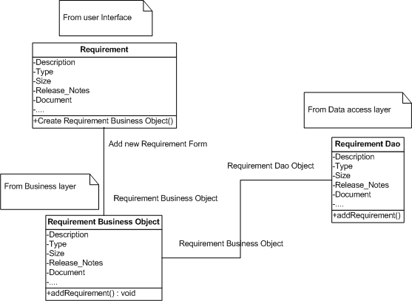

### Sequence flow

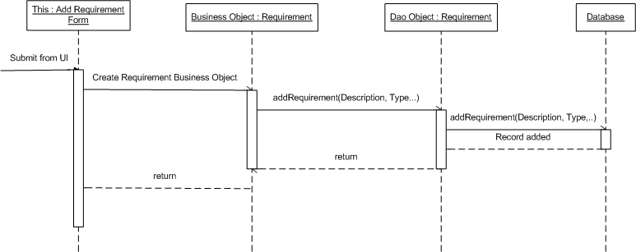

## Requirement _UC02 - Update Requirement Use Case

### Class Diagram

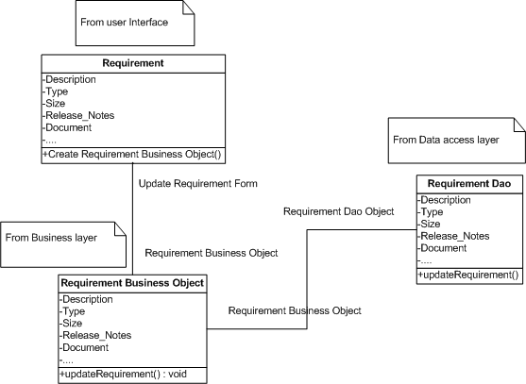

### Sequence flow

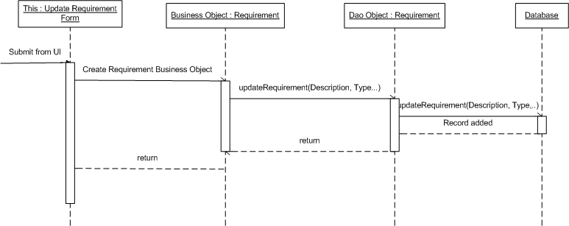

## Requirement _UC03 - Delete Requirement Use Case

### Class Diagram

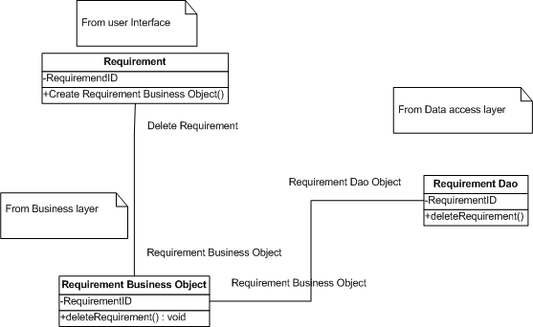

### Sequence flow

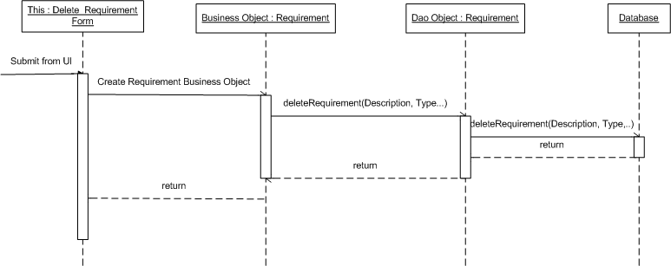

## Requirement _UC04 - Sort Requirements Use Case

### Class Diagram

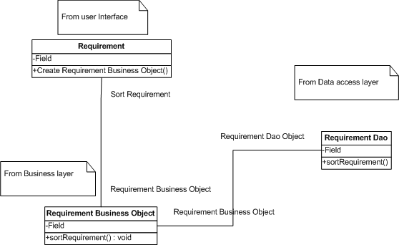

### Sequence flow

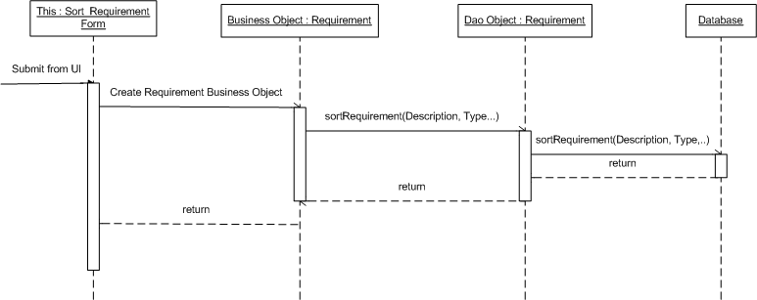

## Use case 01:

### Class Diagram

### Sequense flow

## Use case 01:

### Class Diagram

### Sequense flow

## Use case 01:

### Class Diagram

### Sequense flow

## Use case 01:

### Class Diagram

### Sequense flow

## Use case 01:

### Class Diagram

### Sequense flow

## Use case 01:

### Class Diagram

### Sequense flow

## Use case 01:

### Class Diagram

### Sequense flow

## Use case 01:

### Class Diagram

### Sequense flow

## Use case 01:

### Class Diagram

### Sequense flow

## Use case 01:

### Class Diagram

### Sequense flow

# Interface Design

To be updated.

# Configuration

To be updated.

# Packaging and Deployment

To be updated.

# Appendix

N/A